**“Hazelwood Loft” guidelines:  
A-For best and optimal results please type in those settings in:**   
**1-“Edit / Project setting / Player settings & Quality settings” for normal build:**  
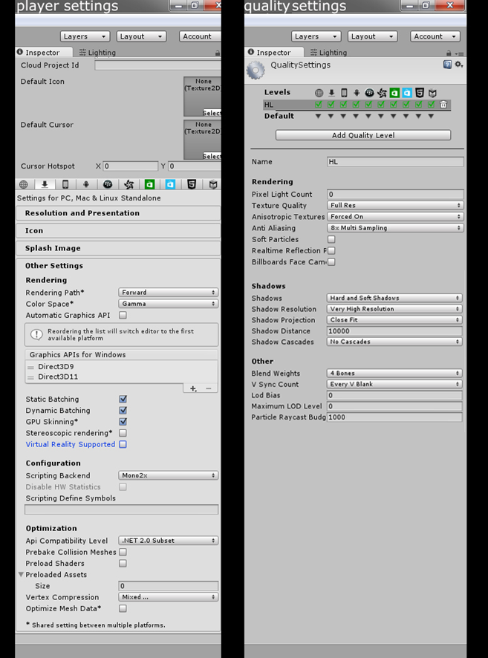  
  
**2-“Edit / Project setting / Player settings & Quality settings” for   
Oculus build:**  
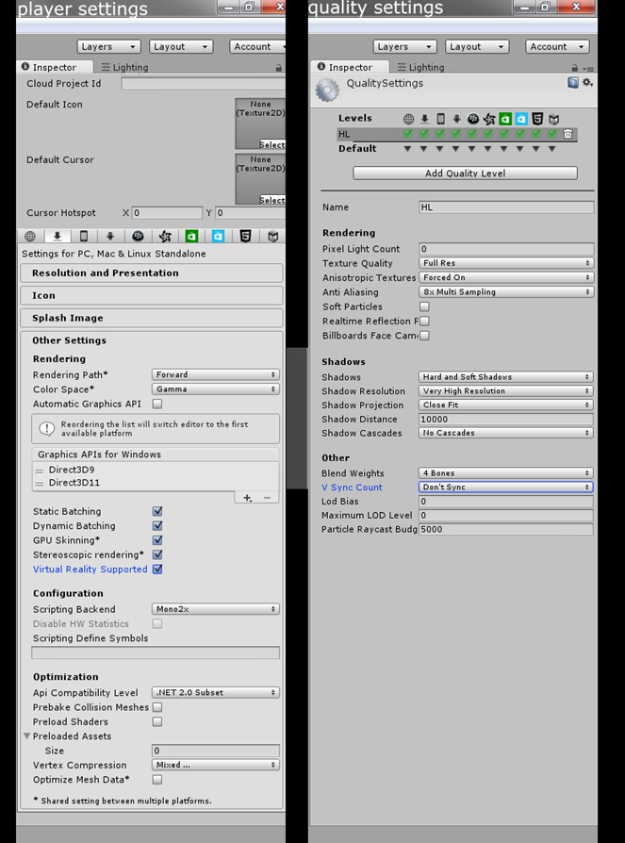  
**3-“Windows / Lighting” options:**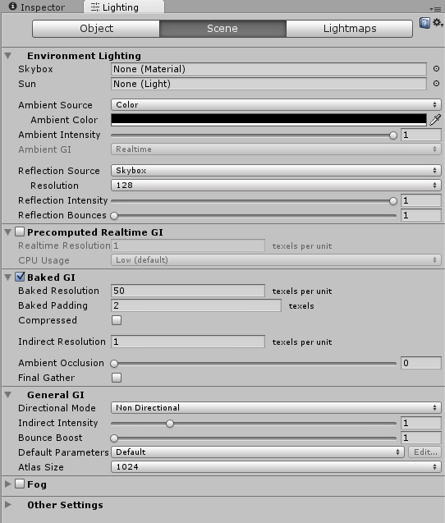  
  
  
  
  
  
  
  
  
  
  
  
 **4-“Lighting” icon is turned ON like this:  
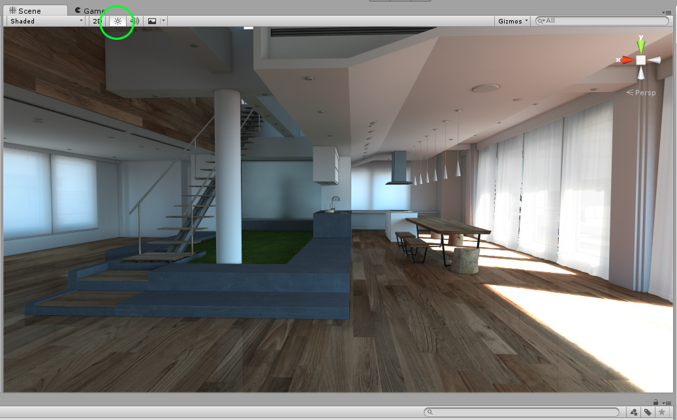  
  
  
  
B-Lighting guidelines:**  
  
**1- The Lightmapping porting manager:**All the lighting in the scene was baked in “Mental Ray” to achieve photorealism, a rayteracer that is used in film, TV and cinema. A plugin was used for this since Unity5 doesn’t let you have custom lightmaps like older versions of Unity. So you can use the current lighting for your build or if you want to use your own lighting, just drop some lights and hit “build”.  
  
**2-duplicating objects:**If you want to duplicate already lightmaped objects, just duplicate the object (it will look weird with no lightmap) then delete the ” LightmappingManager” in the scene, go to “windows/ Lightmaping Porting Manager” and click on “Get Lightmap Data”.  
  
**3-Optimising your scene:**If you want to optimize performance in your scene just select all your objects and delete the “Lightmap Data Script”. And leave the “ LightMappingManager” in the scene.  
  
  
  
  
  
  
**C-Merging different packs:  
  
If you want to merge 2 adjacent rooms, follow these steps:  
-**Import package B to package A.  
-Open the scene containing room A , select “geometry” and copy.  
-Open room B and paste the copied room A.  
-Delete the “LightmappingManager” in the scene.  
-Go to “window/lightmaping porting manager” and click on “Get lightmap Data”  
-Make sure that in the lightmap manager the lightmaps are mapped like this:  
  
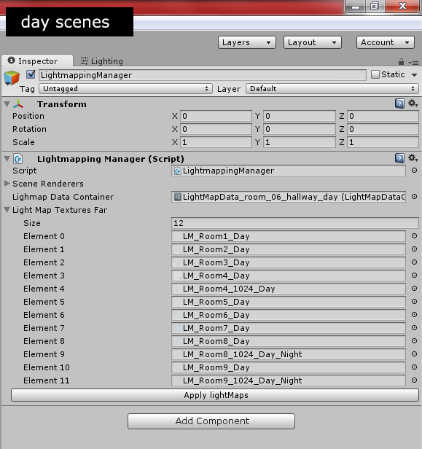

**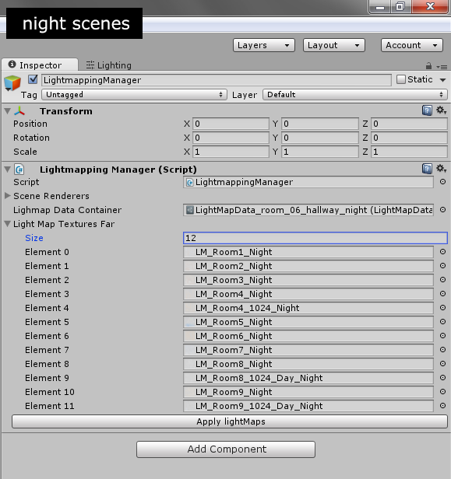  
  
  
D-special notes:**"One or more textures on this 3D-model have been created with images from cgTextures. These images may not be redistributed by default. Please visit cgTextures for more information."  
  
  
  
Enjoy  
POLYBOX